Paladin Project

For this last update, we’ve added some more enemies, added navigation meshes to all enemies, fixed animation issues, added an attack/damage system for players and enemies, added 3 special attacks with animations, and updated weapon scripts.

We faced challenges with animations for the player and the enemies. Neither of us really have any 3D modeling nor could 3D animations experience so some animations don’t work as well as they probably. We also are struggling to find time to work on it due to the semester coming to an end.

Our goals for Monday is to create our first level and implement the user HUD.

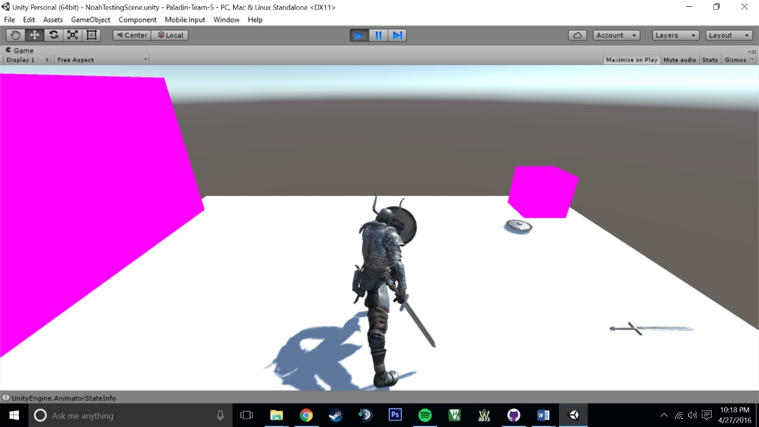

Blocking Special Skill

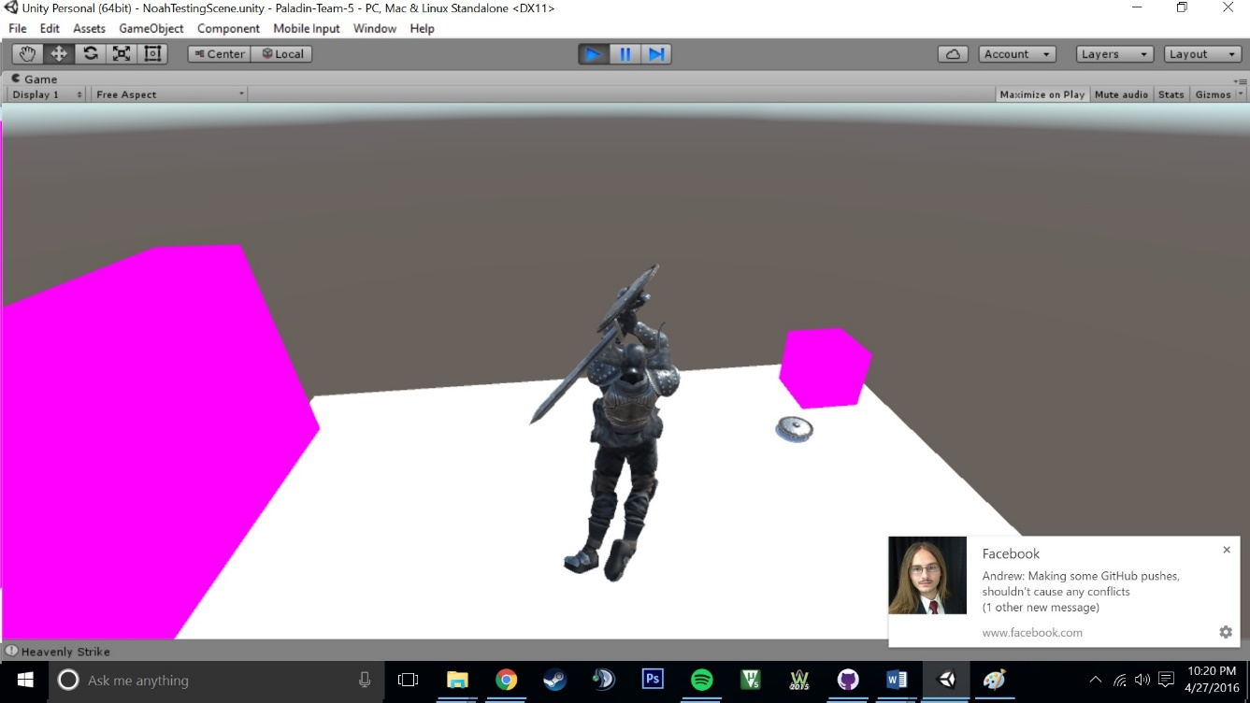

Jump Slash Special Ability

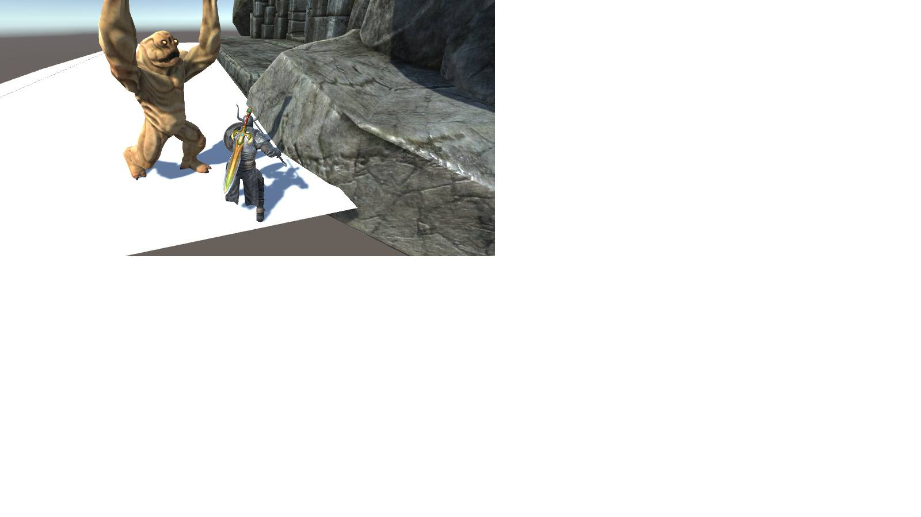

New enemy attacking the player

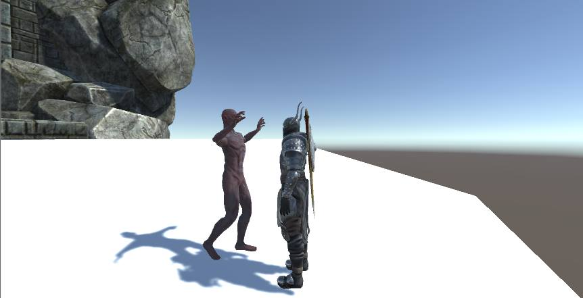

Zombie Attacking our Player

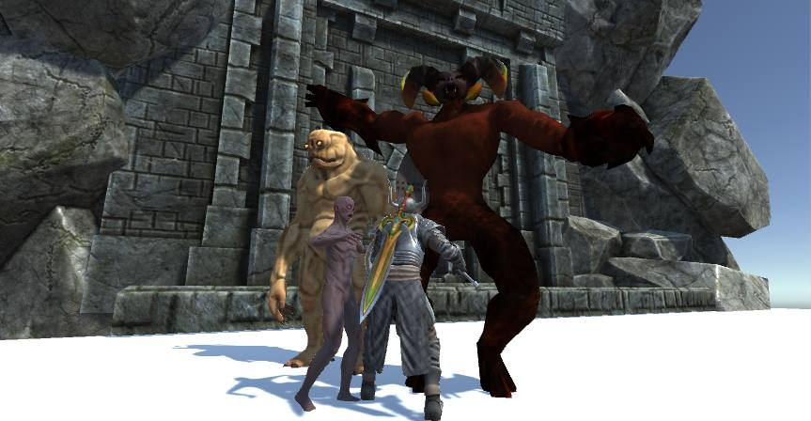

All three enemies got together for a group photo